A GENERAL MEAN WIND VELOCITY PROFILE RELATIONSHIP FOR AN AMAZONIAN RAIN FOREST ENVIRONMENT

Leonardo Deane de Abreu Sá
Museu Paraense Emílio Goeldi – Instituto Nacional de Pesquisas Espaciais/Centro de Previsão de Tempo e Estudos Climáticos – ldsa@museu-goeldi.br

Vanusa Bezerra Pachêco
Ex-bolsista do CNPq

ABSTRACT

We studyed mean wind velocity profiles measured on a 60m height tower built in the forest reserve Jarú (10⁰05'S, 61⁰35'W), belonging to IBAMA institution, located in the brazilian north-western state of Rondonia. The data were collected during LBA (Large Scale Biosphere-Atmosphere Experiment in Amazonia) wet season campaign. The nine cup anemometers whose measurements were used in this work were vertically placed in a way to provide good calculation of the mean velocity wind profile inflexion point value. This allow us to obtain well fitted third degree polinomial functions for the vertical wind profiles. Thus, it was possible to determine with reasonable prevision the following physical parameters: inflexion-point height, z_{i}; inflexion point height wind velocity, u_{i}; mean wind shear in thE CANOPY TOP, s_{h} = (d<u>/dz)|_{h}; characteristic length scale, L_{h} = <u_{h}>/s_{h}, where z is the above surface height. This is useful to obtain above and below canopy nondimensional wind velocity, u/u_{i}, as a function of a nondimensional inside canopy depth (z - z_{i})/L_{h}. The results for more than 300 data points seem to confirm the suggestions that the wind shear in the canopy top and the inflexion point in the wind velocity vertical profile synthetize the basic informations concerning the dynamics of turbulent interactions between the flow above and below the Amazonian forest canopy in Rondonia.

INTRODUCTION

Forest-atmosphere interaction investigations have shown that the atmospheric flows present very complex characteristics as compared whith flow above smooth and horizontally homogeneous surfaces as anomalous turbulent coherent structures and inflection point in the vertical wind profile (Raupach et al., 1996; Finnigan, 2000). Concerning the role of Amazonian forest in biosphere-atmosphere exchanges many subjects related with coupling between above canopy region and below canopy region have been investigated by authors as Shuttleworth et al. (1985), Fitzjarrald et al. (1990), Fitzjarrald and Moore (1990) and Kruijt et al. (2000), among others. However, no systematic research has been done regarding vertical mean wind profile general relationship in the Amazonian forest environment. It is what we perform in this work.

METHODOLOGY
To obtain a general expression for the mean wind velocity profile both above and below the Amazonian forest, we propose a new formulation which takes in account the information provided by the wind velocity vertical profile, particularly the physical scales associated with the its inflexion point and with the wind shear stress at the canopy top height, h.
We propose a characteristic velocity-scale, u_{i}, which is the mean wind velocity at the inflexion point height, z_{i}, and a characteristic length-scale, L_{h}, defined for data obtained at the height h, as shown in Equation 1:
L_{h} = [ <u>/(d<u>/dz) ]|_{h} (1)

Where <.> is the “mean operator” and z is the above ground height
With these characteristic-scales we propose a general scaling relationship for the wind velocity mean vertical profile, as presented in Equation 2, which holds both above and below Amazonian rain forest canopy in Jaru Reserve, Rondônia:
<u>/u_{i} = F[(z_{i} - z)/L_{h}] (2)
where F is a function which would be universal in canopy environment whose mathematical form is to be determined empirically from experimental data.

EXPERIMENTAL DATA

To perform the wind profile analysis we used data provided by nine cup anemometers (Low Power A100L2, Vector Instruments Inc.) ranged in previously define heights to give good resolution information about the inflexion point in the vertical wind profiles and provide useful information about the below canopy, inside canopy and above canopy atmospheric flow. So, wind velocity 1 hour averaged values measured at the heights of 55.00m, 50.55m, 47.70m, 42.90m, 40.25m, 37.80m, 32.85m, 26.65m, and 14.30m above the ground were available.

RESULTS

From a third degree polynomial fitting of 1 Hour mean wind nondimensional profiles, it is possible to show the day time variability of the above canopy inflexion poInt height, z_{i}, as shown in Figure 1.

FIGURE 1. Day-time variability of the inflexion-point height for clear, partially cloudy and cloudy typical days in Rebio Jaru Reserve forest.

TABLE 1 – Day-time variability of some characteristic micrometeorological parameters associated with inflexion point in mean velocity profile for Julian day 62.
Local time  (Hour) | Least squares $R^{2}$ | $u_{i}$  (m/s) | $z_{i}$  _{(m)} | $\frac{\text{du}}{\text{dz}}|_{h}$  (s⁻¹) | L_{h}  _{(m)}
0 | 0,9735 | 1,1422 | 41,5996 | 0,0677 | 16,8642
1 | 0,9225 | 1,1780 | 43,7966 | 0,0686 | 17,1679
2 | 0,9266 | 0,7898 | 40,5327 | 0,0488 | 16,1828
3 | 0,9021 | 0,8081 | 39,8824 | 0,0529 | 15,2651
4 | 0,7937 | 0,5302 | 49,1369 | 0,0267 | 19,8909
5 | 0,8650 | 0,6506 | 43,4032 | 0,0273 | 23,8062
6 | 0,9791 | 0,5609 | 42,8703 | 0,0223 | 25,1977
7 | 0,9908 | 0,4782 | 37,0361 | 0,0178 | 26,9086
8 | 0,9900 | 0,8227 | 38,2394 | 0,0432 | 19,0651
9 | 0,9969 | 1,8253 | 39,3132 | 0,1213 | 15,0488
10 | 0,9971 | 1,7898 | 38,9048 | 0,1226 | 14,6029
11 | 0,9938 | 1,7098 | 38,1167 | 0,1196 | 14,2992
12 | 0,9994 | 1,4380 | 39,5207 | 0,0926 | 15,5309
13 | 0,9950 | 1,9409 | 38,5240 | 0,1124 | 17,2731
14 | 0,9959 | 1,3432 | 38,0931 | 0,0854 | 15,7260
15 | 0,9821 | 1,1799 | 38,1161 | 0,0668 | 17,6749
16 | 0,9971 | 2,1384 | 37,8951 | 0,1377 | 15,5287
17 | 0,9723 | 0,8864 | 42,5047 | 0,0466 | 19,0066
18 | 0,9949 | 1,4625 | 40,0540 | 0,0920 | 15,8952
19 | 0,9526 | 1,1235 | 43,2185 | 0,0677 | 16,6032
20 | 0,9886 | 0,8540 | 40,5640 | 0,0458 | 18,6560
21 | 0,9354 | 0,6488 | 39,8194 | 0,0360 | 18,0464
22 | 0,7893 | 0,8322 | 45,6928 | 0,0165 | 50,2913
23 | 0,9631 | 0,9901 | 40,7296 | 0,0635 | 15,5908

A  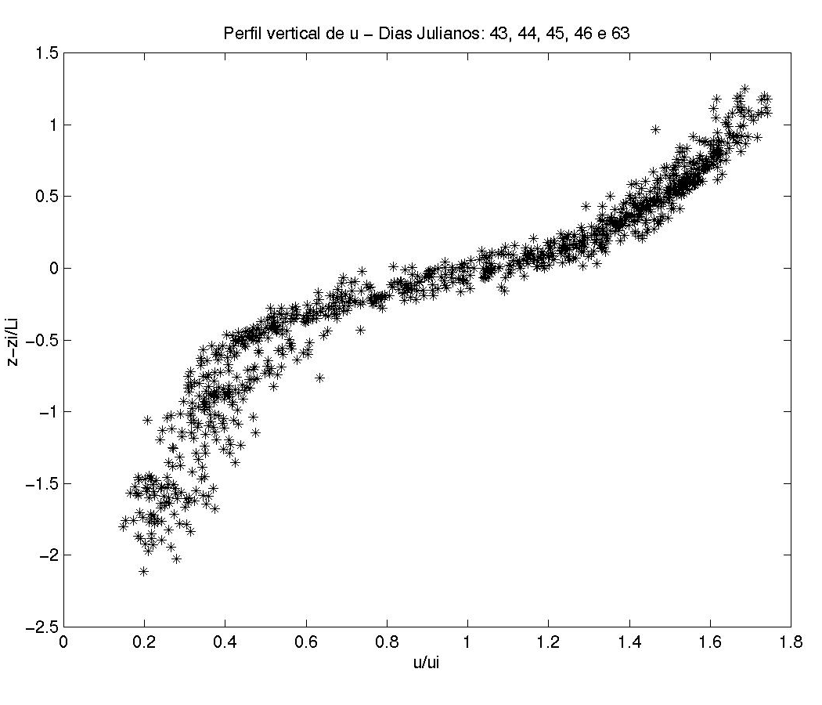 | B  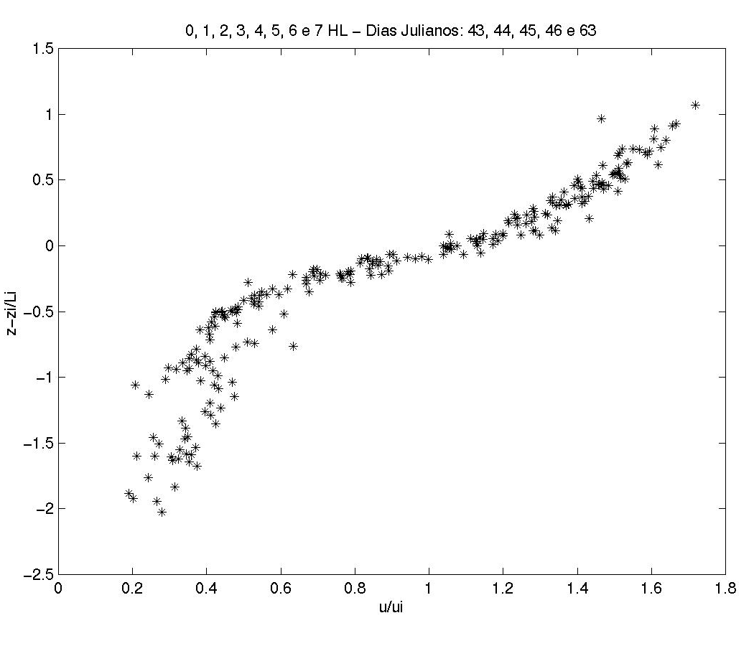
C  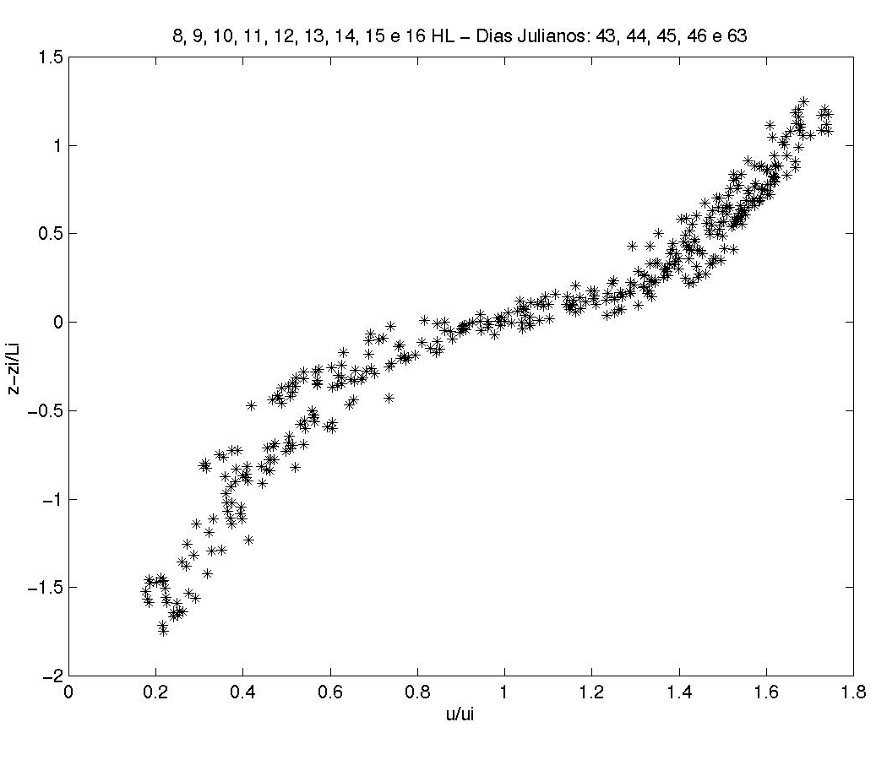 | D  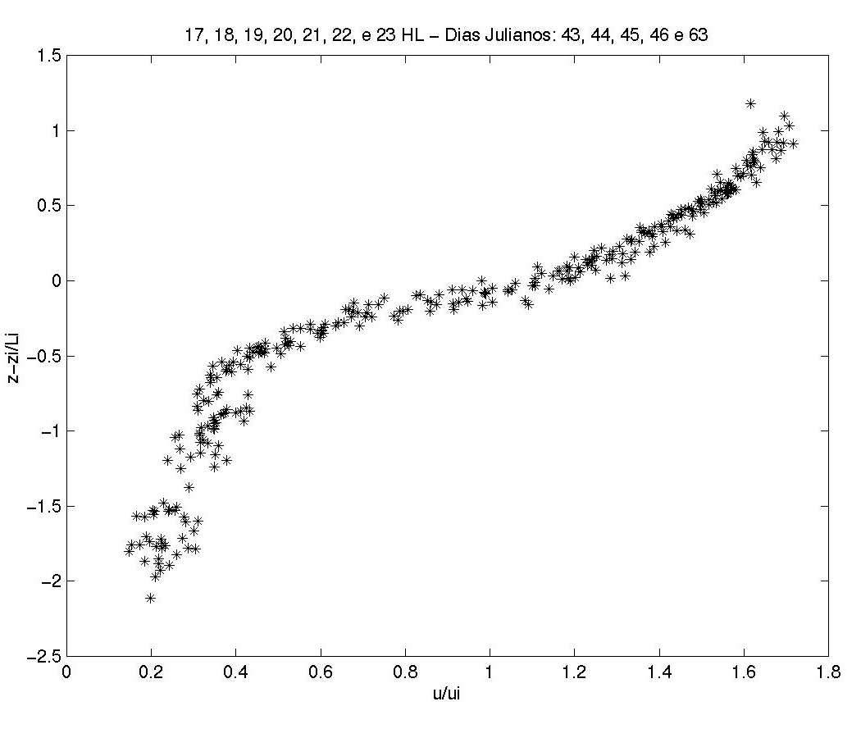

FIGURE 2 Presents [<u>/u_{i} ] X [(z-z_{i})/L_{h}] plots for data obtained under clear-sky onditions: (A) all avaliable data; (B) daytime data; (C)early nigth data; (D) late night data.

We observe that all figures depict very well fitted nondimensional velocity profiles irrespectively of the local time observation period. Similar results have been obtained for cloudy and partially cloudy sky conditions (not shown). All polynomial curves presented the determination coefficient R² > 0.90. The best fit was for clear sky nights (R² = 0.96), and the worst, for partially covered early mornings (R² = 0.92). It is important to point out that these polynomial fittings were obtained irrespectively to any stability condition constrain. One possible explanation for this result is that many thermal forcing inflences are in some way embedded in the scaling parameters. However, some few fluctuations between data-points and the fitted curve are observed. This is probably due to thermal non homogeneity of the canopy, which would be associated with the complex geometrical characteristics of vegetation crown. As consequence, inside canopy temperature gradients could be created and local thermaly induced cells would disturb the mean wind profile characteristics. To obtain more insight about this problem, we present in FIGURE 3 the plot of the nondimensional wind velocity standard deviation for several [( z - z_{i} )/L_{h}] nondimensional height values. The inerval –0.5< [( z - z_{i} )/L_{h}] <0 is the one which presents more scatter in the standard deviation of wind velocity. This is because this nondimensional interval corresponds to the region located between the inflexion point and the highest part of the forest canopy, where we expect the wind velocity shear stress is more intensive. this tendency is observed in al analysed data classes.

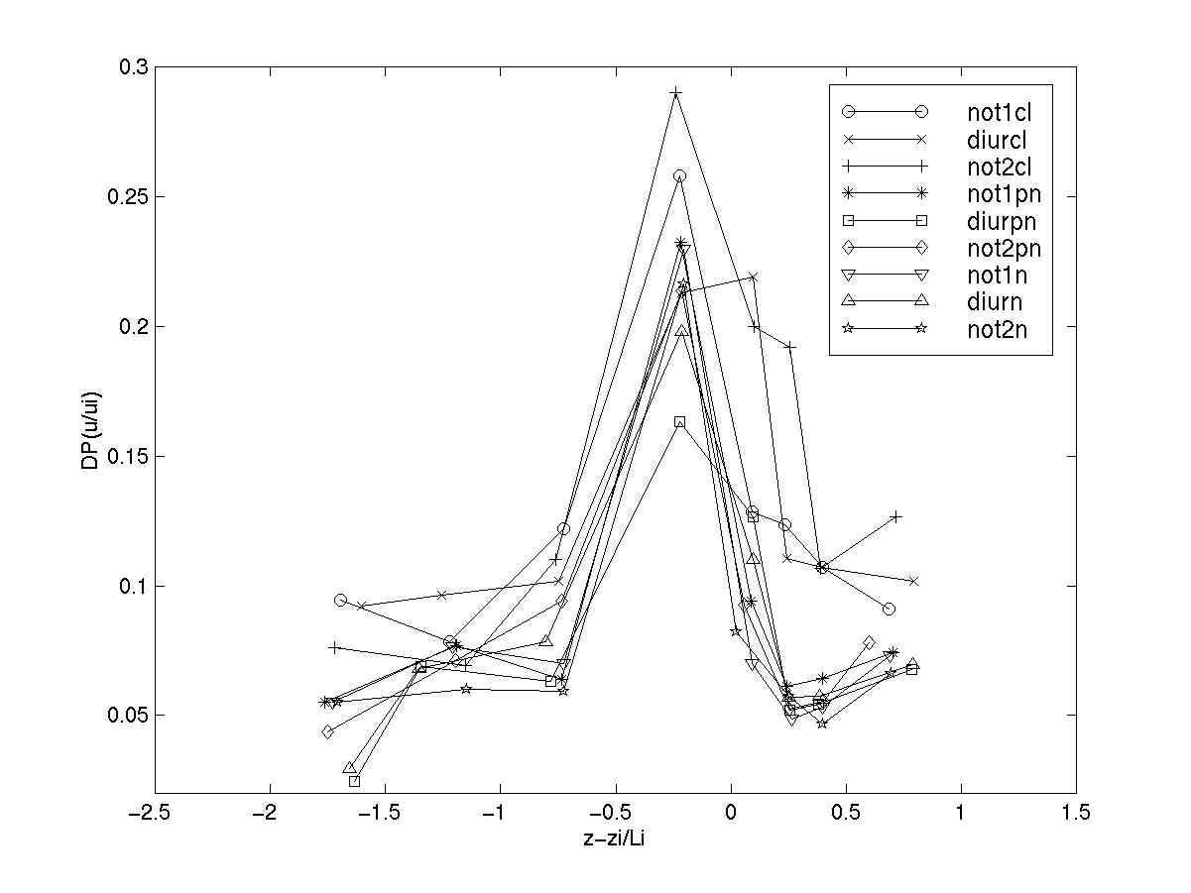
FIGURE 4 - Nondimensional wind velocity standard deviation, Dp, for several
[( z - z_{i} )/L_{h}] intervals - Eeach symbol corresponds to a defined data-class: not1 - late night; diur – day time; not2 – early night; cl – clear sky; pn – partially cloudy sky; n, cloudy sky.

CONCLUSIONS

Mean wind velocity profiles measured above and inside Rebio Jaru Forest Reserve in Western Amazonia have bean analysed. It is demonstrated that it is possible to obtain nondimensional general relationship for the wind profile. It is shown that the wind shear at the canopy top and at the wind velocity inflexion point provide the only physical information needed to perform wind velocity profile scaling. This seems to indicate that the turbulent momentum exchange is more important than thermal transfer in defining the main aspects of canopy turbulent processes. It was observed that the wind velocity profile inflexion point reaches its lowest height when there are unstable conditions above forest canopy. Such cases, the boundary layer just above the trees is highly unstable and this helps to transfer momentum flux to the upper part of the forest canopy. Additional reasearch isneeded to investigate the scaling characteristics of mean scalar profiles above and inside the canopy.

ACKNOWLEDGEMENTS

This work is part of the Large-Scale Biosphere-Atmosphere Experiment in Amazonia (LBA) and was supported by the Fundação do Amparo à Pesquisa do Estado de São Paulo (FAPESP)/Brazil – process N⁰ 1997/9926-9. We thank Dr. Maria Assunção Faus da Silva Dias who was the coordinator of this research project. The authors are also greatful to INCRA/Ji-Paraná and to IBAMA/Ji-Paraná. Leonardo Sá acknowledges the support from Conselho Nacional de Dsenvolvimento Científico e Tecnológico (CNPq), productivity in research grant Nº 300.329/1996 2NV and Vanusa Pacheco the fellowships from Coordenação de Aperfeiçoamento de Pessoal de Nível Superior (CAPES) and from CNPq.

REFERENCES

Finnigan, J. J. and R. H. Shaw, "A Wind-Tunnel Study of Airflow in Waving Wheat: An EOF Analysis of the Structure of the Large-Eddy Motion", Boundary-Layer Meteorology, 96, 1-2: 211-255, August, 2000.

Fitzjarrald, D. R. and K. E. Moore, "Mechanisms of Nocturnal Exchange Between the Rain Forest and the Atmosphere", Journal of Geophysical Research, 95, D10: 16839-16850, September 20, 1990.

Fitzjarrald, D. R., K. E. Moore, O. M. R. Cabral, J. Scolar, A. O. Manzi and L. D. A. Sá, "Daytime Turbulent Exchange Between the Amazon Forest and the Atmosphere", Journal of Geophysical Research, 95, D10: 16825-16838, September 20, 1990.

Kruijt, B., Y. Malhi, J. Lloyd, A. D. Nobre, A. C. Miranda, M. G. P. Pereira, A. Culf and J. Grace, "Turbulence Statistics Above and Within Two Amazon Rain Forest Canopies", Boundary-Layer Meteorology, 94, 2: 297-331, February, 2000.

Raupach, M. R., J. J. Finnigan and Y. Brunet, "Coherent Eddies and Turbulence in Vegetation Canopies: The Mixing-layer Analogy", Boundary-Layer Meteorology, 78, 3-4: 351-382, March, 1996.

Shuttleworth, J. W., J. H. C. Gash, C. R. Lloyd, C. J. Moore, J. Roberts, A. O. Marques Filho, G. F. Fisch, V. P. Silva Filho, M. N. G. Ribeiro, L. C. B. Molion, L. D. A. Sá, C. A. Nobre, O. M. R. Cabral, S. R. Patel and J. C. Moraes, "Daily Variations of Temperature and Humidity within and above Amazonian Forest", Weather, 40, 4: 102-108, 1985.

